Student Name: Yuvraj Kathpal SAP ID: 1000020078 Section: D
Student Name: Yashika Arora SAP ID: 1000020118 Section: D
Student Name: Dhanya Verma SAP ID: 1000020238 Section: D
Project Chosen: P6 – Automated Bug Tracking System
For this project, you will solve problems based on what you have learned in this course.
Instructions // These are sample instructions, you may keep relevant ones and remove/add rest as required.
- The project must be developed using appropriate platform for Design and Code.
- Mention names and IDs of all group members on the top of this document.
- There are 6 projects in this assignment. Attempt any one of them, and mention which project you have chosen on the top of this page.
- Project submitted after due date will not be evaluated and a score of zero will be awarded.
- Upload a word version of the document.
- The group size should not be more than 3, and the group must be formed from the same section. Inter section groups will not be accepted.
- Plagiarism may lead to award of zero marks.
- If you have doubts about any project, please contact the course instructor.
Due Date: As per LMS / Faculty Instructions
Submitting this Assignment
You will submit (upload) this assignment in LMS. Email/paper submissions will not be accepted.
- Write your answer (codes and snapshots of module interface, input and output) after the question in this document.
- Name this document as Project_SEEVEN2026_1000020078_1000020118_1000020238.doc
Grading Scheme: This project has 10 marks. Marks distribution is as follows:
- Appropriate GUI for Module interface, input and output as mentioned in the question: 4 marks,
- Expected input and Output as mentioned in the question: 3 marks,
- Well documented code, Presentation = 3 marks.
// Where 4+3+3 = 10

1. Introduction and Objective
Bug tracking is a critical activity in the Software Development Life Cycle (SDLC). Manual tracking via spreadsheets or emails is error-prone and lacks real-time visibility. BugTrack v3.0 is a centralized web-based Automated Bug Tracking System that enables teams to report, categorize, assign, and resolve software defects in a structured and traceable manner.
Objective: To develop a centralized platform where developers can report, categorize (Critical, Major, Minor), and track the status of software bugs during a project, with role-based access for Admin, Developer, and Tester roles and real-time in-app notifications.
1.1 Key Features
- Centralized bug reporting with severity classification: Critical, Major, Minor.
- Role-based access control — Admin, Developer, Tester — each with distinct permissions.
- Real-time analytics dashboard: bar chart, donut chart, and time-series chart.
- Bug lifecycle management: Open → In Progress → Resolved → Closed.
- In-app notification system with unread badge and Mark all read functionality.
- Filterable bug list with assignee tracking, severity and status badges.

2. SDLC Model Adopted — Iterative Model
The Iterative Model was chosen for BugTrack because the system could be broken into independent, deliverable increments (Authentication, Bug Management, Dashboard and Notifications) each built, tested, and refined before moving to the next. Unlike Waterfall, the Iterative Model allows defects found in one iteration to be corrected before the next begins — which is especially appropriate for a bug tracking system itself.
2.1 Why Iterative Model?
- The system has clearly separable modules that can be developed and tested independently.
- Each iteration produces a working, testable increment — reducing integration risk.
- Feedback from one iteration can be incorporated into the design of the next.
- Errors are detected early, per iteration, rather than all at the end (as in Waterfall).
- The iterative approach mirrors real-world software project management taught in SE.
2.2 Iterations of Development
Iteration | Duration | Work Done | Output | Status
Iteration 1 (Foundation) | Week 1–2 | Requirement gathering, system design (MVC architecture, DB schema, API contract). User Authentication module: Register, Login, JWT middleware, role-based access. MongoDB User schema. | Working login system with 3 roles | Done
Iteration 2 (Core Module) | Week 3–4 | Bug Reporting Form (all fields, validation). Bug List with severity and status filters. Advance Status feature (lifecycle progression). MongoDB Bug schema. REST API: GET/POST/PATCH /api/bugs. | Full bug CRUD with lifecycle | Done
Iteration 3 (Analytics & Notifications) | Week 5–6 | Admin Dashboard (KPI cards, bar chart, donut chart, time-series via Recharts). Notification system (auto-create on report/status change, in-app panel, mark all read). Full UI polish and integration testing. | Complete working system | Done
2.3 Iterative Model Phases (per Iteration)
Each of the three iterations followed the same internal cycle of phases:
Planning: Define goals, scope, and deliverables for the current iteration.
Requirements: Identify specific functional and non-functional requirements for this iteration's modules.
Design: Create module-level design: API endpoints, component structure, DB fields needed.
Implementation: Code the module (backend routes + frontend React components).
Testing: Unit test each API endpoint (Postman); integration test with the frontend.
Review: Evaluate output against requirements; identify issues to carry into the next iteration.

3. Software Requirements Specification (SRS)
3.1 Functional Requirements
- FR1 — Users shall register and log in using email and password with JWT-based authentication.
- FR2 — The system shall support three roles: Admin, Developer, and Tester, each with different access levels.
- FR3 — Authenticated users shall submit bug reports with fields: Title, Severity, Priority, Module, Assign To, Environment, and Description.
- FR4 — The system shall display all bugs in a filterable Bug List (filter by severity and status).
- FR5 — Authorized users shall advance a bug through: Open → In Progress → Resolved → Closed.
- FR6 — The Dashboard shall show KPI cards: Total Bugs, Critical, In Progress, and Resolved counts.
- FR7 — The Dashboard shall render a bar chart (Bugs by Severity) and a donut chart (Status Breakdown).
- FR8 — The system shall auto-generate in-app notifications on new bug reports and every status change.
- FR9 — Users shall mark all notifications as read, resetting the unread badge count.
- FR10 — Demo accounts shall be seeded via POST /api/auth/seed for Admin, Developer, and Tester roles.
3.2 Non-Functional Requirements
- NFR1 — Performance: API response time under 500ms for all standard CRUD operations.
- NFR2 — Security: All routes except /login and /seed protected by JWT middleware.
- NFR3 — Usability: UI responsive on screen widths of 1280px and above.
- NFR4 — Maintainability: Code follows MVC — routes, controllers, and models in separate directories.
- NFR5 — Scalability: MongoDB schema extendable to multiple projects without structural change.
- NFR6 — Reliability: System returns appropriate HTTP codes (400, 401, 404, 500) for all error cases.

4. System Design
4.1 Architecture — MVC Pattern
BugTrack follows the Model-View-Controller (MVC) architectural pattern, separating data logic, business logic, and presentation into three distinct layers:
Layer | Technology | Responsibility
Model | MongoDB + Mongoose | Data schemas: User, Bug, Notification. All DB queries handled here.
View | React.js + Tailwind CSS | UI components: Login, Dashboard, BugList, ReportBug, Notifications.
Controller | Node.js / Express.js | API route handlers: /api/auth, /api/bugs, /api/notifications.
4.2 Technology Stack
Component | Technology / Tool
Frontend Framework | React.js (Vite build tool)
Styling | Tailwind CSS
Backend Framework | Node.js with Express.js
Database | MongoDB Atlas (Cloud NoSQL)
ODM | Mongoose
Authentication | JSON Web Tokens (JWT) + bcryptjs
Charts | Recharts (React charting library)
API Testing | Postman
Version Control | Git / GitHub
4.3 Database Schema (MongoDB Collections)
Collection | Fields | Purpose
User | _id, name, email, password (hashed), role | Stores users. Role: Admin / Developer / Tester.
Bug | _id, title, severity, priority, module, environment, description, status, assignee, reportedBy, createdAt | Each bug report. Status: Open / In Progress / Resolved / Closed.
Notification | _id, message, bugId, triggeredBy, type, isRead, createdAt | Auto-created on report or status change. type: new-bug or status-change.
4.4 Use Case Summary
Use Case | Actor | Trigger | Outcome
UC1: Login | All Users | Submit credentials | JWT token issued, redirect to Dashboard.
UC2: Report Bug | Dev / Tester | Submit form | Bug saved, notification auto-created.
UC3: View Bug List | All Users | Navigate to Bug List | All bugs shown with filters.
UC4: Advance Bug | Admin / Dev | Click Advance | Status updated, notification triggered.
UC5: View Dashboard | Admin | Navigate to Dashboard | Charts and KPI cards rendered live.
UC6: View Notifications | All Users | Click Notifications | All alerts listed with New badge.
UC7: Mark All Read | All Users | Click Mark all read | All notifications marked read, badge reset.
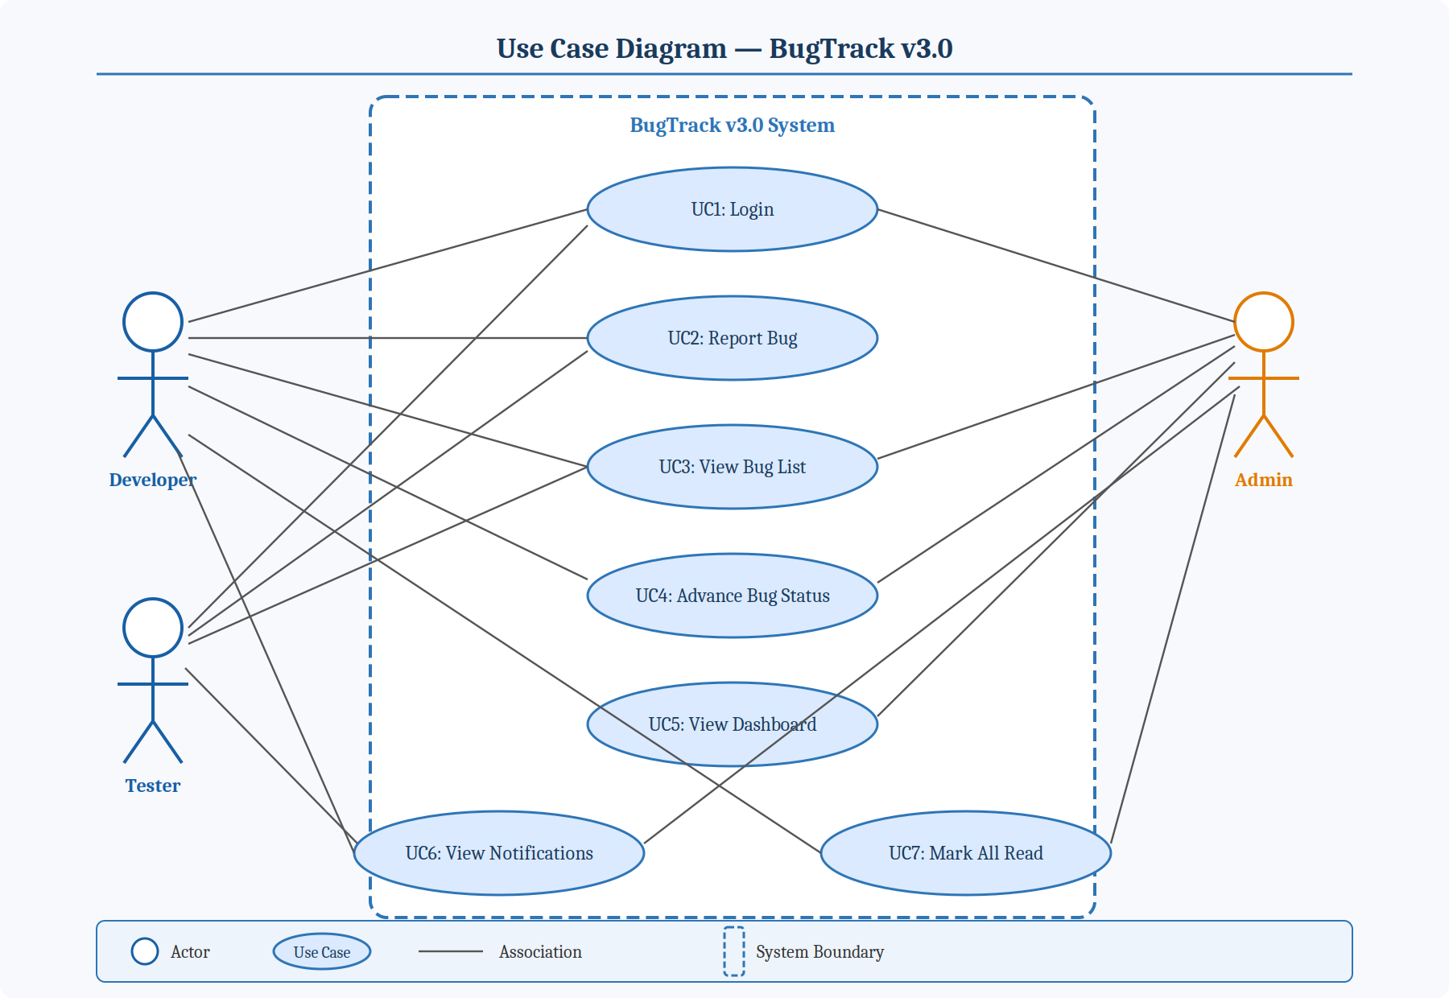
Figure 1: Use Case Diagram — BugTrack v3.0
4.5 Data Flow — Bug Reporting
Step 1: User logs in → POST /api/auth/login → JWT token returned → stored in browser.
Step 2: User fills Report Bug form → submits → POST /api/bugs called with JWT in header.
Step 3: Express controller validates fields → saves Bug to MongoDB → creates Notification document.
Step 4: Bug List page loads → GET /api/bugs → all bugs rendered in filterable table.
Step 5: User clicks Advance → PATCH /api/bugs/:id → status updated → new Notification created.
Step 6: Notifications panel → GET /api/notifications → all alerts rendered with read/unread state.
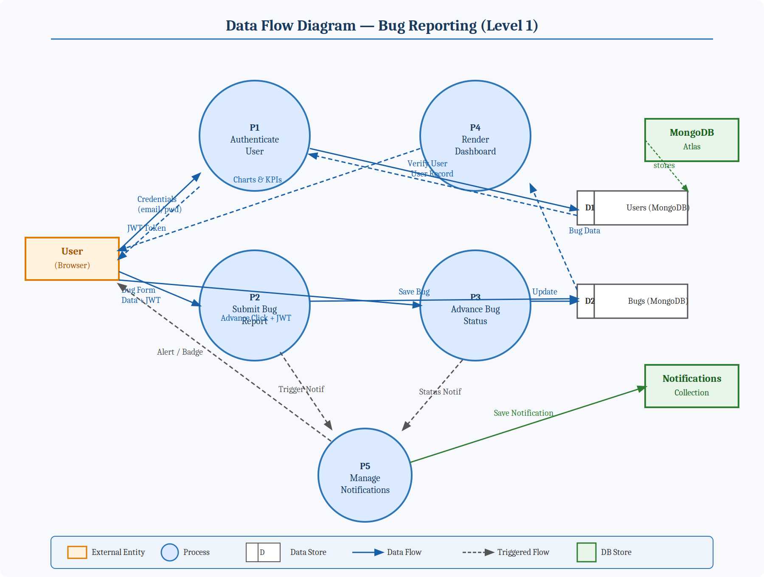
Figure 2: Data Flow Diagram (Level 1) — BugTrack v3.0

5. Core Modules Description
5.1 User Authentication (Dev / Admin / Tester)
Role-based login using email and password. JWT issued on success and attached to all API requests. Passwords hashed with bcryptjs. Three demo roles seeded via POST /api/auth/seed: Admin (Yashika Arora — full access), Developer (Yuvraj Kathpal — report and advance bugs), Tester (Dhanya Verma — report bugs only).
5.2 Bug Reporting Form
Validated form with required fields (*): Bug Title, Severity (Critical / Major / Minor), Description. Optional: Priority (High / Medium / Low), Module (free text, e.g. Auth, Dashboard), Assign To (dropdown), Environment (e.g. Chrome 122, Windows 11). On submit: POST /api/bugs → bug saved → notification created.
5.3 Dashboard (Status Charts)
Live KPI cards: Total Bugs (8), Critical (4, needs action), In Progress (1, active), Resolved (2, fixed). Three Recharts visuals: bar chart (severity), donut chart (status breakdown), line chart (reported vs resolved — last 7 days). All data fetched live from MongoDB.
5.4 Bug List and Status Advancement
Responsive table: ID (hex), Title, Severity (colour badge), Status (colour badge), Assignee, Date, Actions. Dropdowns filter independently by severity and status. Advance button → PATCH /api/bugs/:id → moves bug to next stage: Open → In Progress → Resolved → Closed → notification auto-created.
5.5 Notification System (In-App)
All events (new report or status change) auto-create a Notification document. Panel shows them in reverse-chronological order: red dot = new report, blue dot = status change. Each entry shows reporter name, time elapsed, and bug title. Unread badge on sidebar. PATCH /api/notifications/mark-read resets count.

6. Module Screenshots (Interface, Input and Output)
6.1 Login Page
Input: email + password. Output: JWT token issued, redirect to Dashboard. Demo buttons auto-fill credentials for Admin (Yashika), Developer (Yuvraj), Tester (Dhanya).
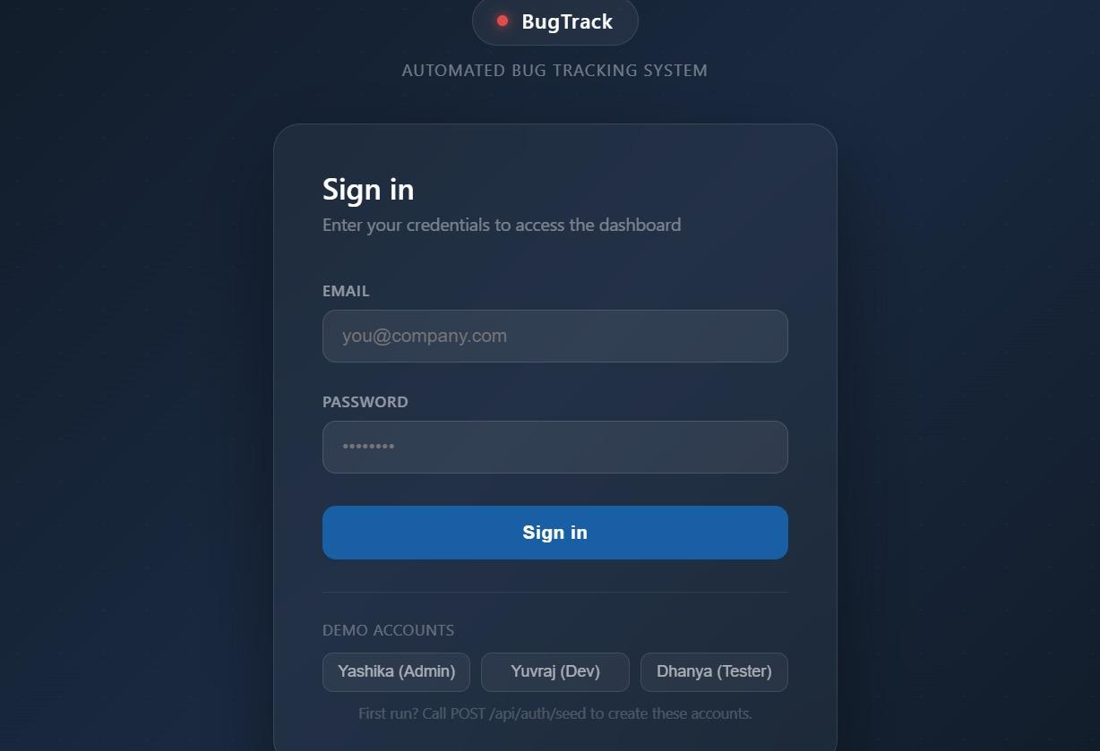
Figure 1: Login Page — Sign In Screen
6.2 Admin Dashboard
Input: None (auto-loaded). Output: KPI cards — Total: 8, Critical: 4, In Progress: 1, Resolved: 2. Bar chart (severity) and donut chart (status) rendered from live MongoDB data.
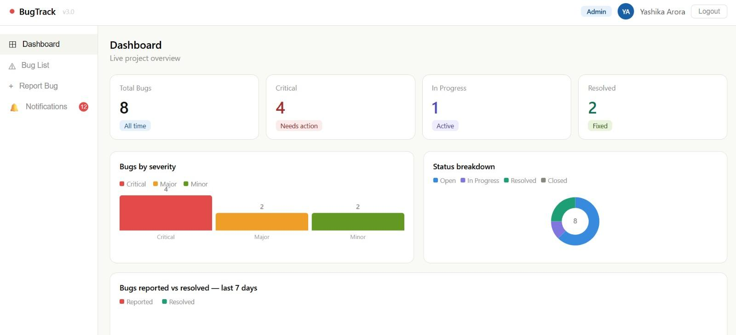
Figure 2: Admin Dashboard — Live Charts and KPI Cards
6.3 Bug List
Input: Severity and Status filter dropdowns. Output: Filtered table of 8 bugs with colour-coded severity/status badges, assignee names, dates, and Advance buttons.
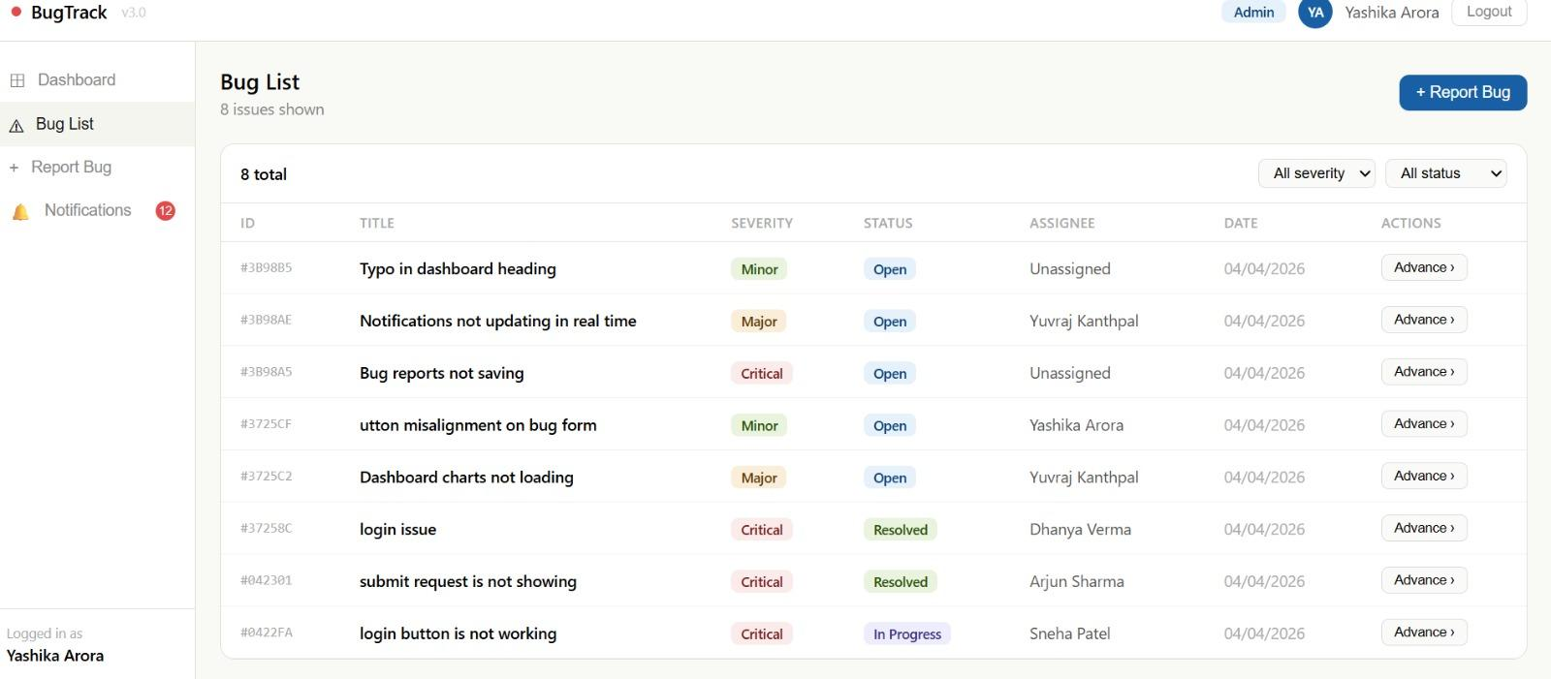
Figure 3: Bug List — Filterable Issue Tracker
6.4 Report a Bug Form
Input: Title *, Severity *, Priority, Module, Assign To, Environment, Description *. Output: Bug saved to MongoDB, notification created, form cleared on success.
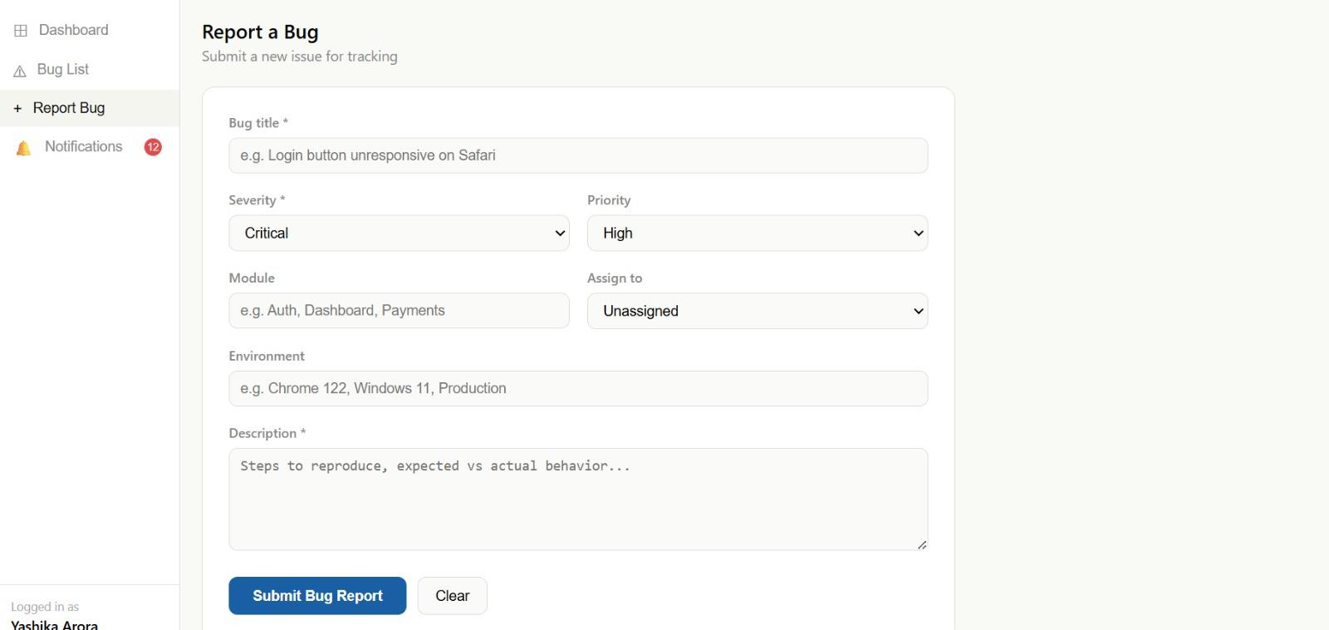
Figure 4: Report a Bug — Bug Submission Form
6.5 Notification System
Input: None (auto-loaded). Output: 12 notifications — red dots for new reports, blue dots for status changes — with reporter, elapsed time, and bug title. Mark all read resets badge.
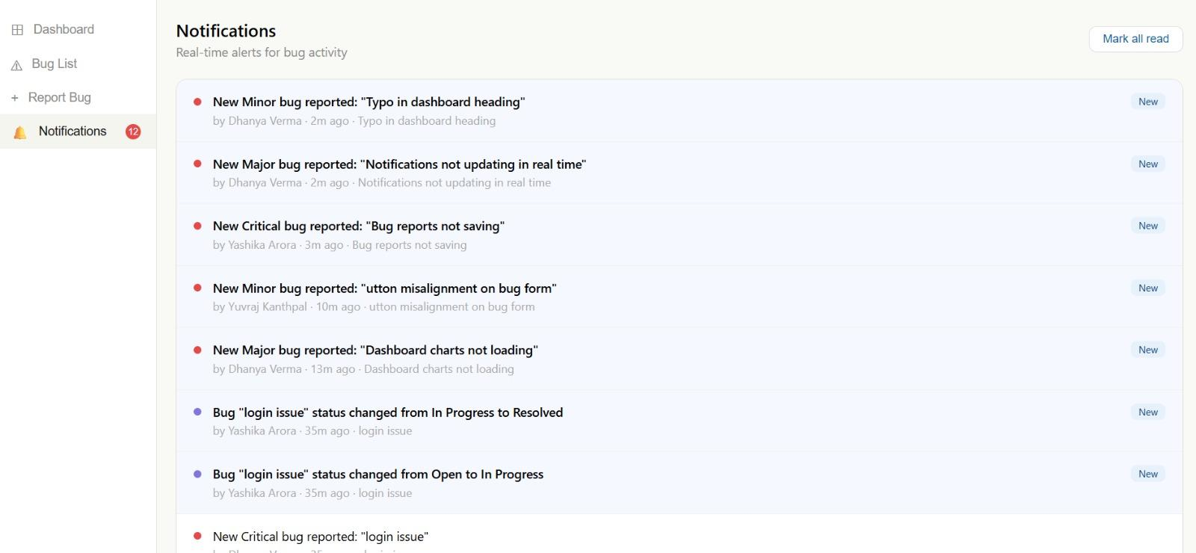
Figure 5: Notifications Panel — Real-time Activity Alerts

7. Testing
Testing was performed per-iteration (unit → integration → UAT) using Postman for API testing and manual browser testing for UI. The following 10 test cases cover all core modules:
# | Test Case | Input | Expected Output | Actual Output | Result
TC1 | Valid Login | Correct email + password | JWT returned, Dashboard loaded | JWT returned, Dashboard loaded | PASS
TC2 | Invalid Login | Wrong password | 401 Unauthorized error | 401 error shown | PASS
TC3 | Submit Bug Report | All required fields filled | Bug saved, notification created | Bug in list, notification shown | PASS
TC4 | Missing Title | Title field empty | Validation error shown | Form rejected with error | PASS
TC5 | Advance Bug Status | Bug in Open, click Advance | Status → In Progress | Badge updated to In Progress | PASS
TC6 | Filter by Severity | Select Critical in dropdown | Only Critical bugs shown | Table filtered correctly | PASS
TC7 | Dashboard Charts | Login as Admin | Charts render with correct data | Bar + donut charts correct | PASS
TC8 | New Bug Notification | Submit a new bug | Notification in panel | Notification appears instantly | PASS
TC9 | Mark All Read | Click Mark all read | Badge resets to 0 | Badge cleared | PASS
TC10 | Unauthorized API Access | Call /api/bugs without JWT | 401 Unauthorized | 401 returned | PASS
All 10 test cases passed. API tested via Postman before frontend integration. Edge cases handled: missing required fields, expired JWT, and duplicate seed calls (idempotent).

8. Source Code
Paste the complete source code for each file in the respective subsections below. Include comments in your code.
-Backend:
8.1 server.js — Express Entry Point
require("dotenv").config();
const express = require("express");
const mongoose = require("mongoose");
const cors = require("cors");
const app = express();
app.use(cors({
origin: process.env.CLIENT_URL || "http://localhost:3000",
methods: ["GET", "POST", "PUT", "PATCH", "DELETE"],
allowedHeaders: ["Content-Type", "Authorization"],
}));
app.use(express.json());
// Routes
app.use("/api/auth", require("./routes/authRoutes"));
app.use("/api/bugs", require("./routes/bugRoutes"));
app.use("/api/notifications", require("./routes/notifRoutes"));

app.get("/", (req, res) => res.send("BugTracker API running"));
// MongoDB connection
mongoose.connect(process.env.MONGO_URI)
.then(() => console.log("MongoDB connected"))
.catch(err => {
console.error("MongoDB connection error:", err.message);
process.exit(1);
});
const PORT = process.env.PORT || 5000;
app.listen(PORT, () => console.log(`Server running on port ${PORT}`));
8.2 auth.js — Authentication Routes
const jwt = require("jsonwebtoken");

module.exports = function authMiddleware(req, res, next) {
const authHeader = req.headers.authorization;
if (!authHeader || !authHeader.startsWith("Bearer ")) {
return res.status(401).json({ error: "No token provided" });
}
const token = authHeader.split(" ")[1];
try {
const decoded = jwt.verify(token, process.env.JWT_SECRET);
req.user = decoded; // { id, name, email, role }
next();
} catch (err) {
return res.status(401).json({ error: "Invalid or expired token" });
}
};
8.3 bugs.js — Bug CRUD Routes(Model)
const mongoose = require("mongoose");
const bugSchema = new mongoose.Schema({
title: { type: String, required: true, trim: true },
description: { type: String, required: true },
severity: { type: String, enum: ["Critical", "Major", "Minor"], required: true },
status: { type: String, enum: ["Open", "In Progress", "Resolved", "Closed"], default: "Open" },
assignee: { type: String, default: "Unassigned" },
assigneeId: { type: mongoose.Schema.Types.ObjectId, ref: "User", default: null },
module: { type: String, default: "" },
environment: { type: String, default: "" },
priority: { type: String, enum: ["High", "Medium", "Low"], default: "Medium" },
reportedBy: { type: String, default: "" },
reportedById:{ type: mongoose.Schema.Types.ObjectId, ref: "User", default: null },
date: { type: Date, default: Date.now }
}, { timestamps: true });
module.exports = mongoose.model("Bug", bugSchema);
8.4 notifications.js — Notification Model
const mongoose = require("mongoose");
const notificationSchema = new mongoose.Schema({
message: { type: String, required: true },
type: { type: String, enum: ["status_change", "new_bug", "assignment", "escalation"], default: "new_bug" },
bugId: { type: mongoose.Schema.Types.ObjectId, ref: "Bug" },
bugTitle: { type: String },
triggeredBy: { type: String }, // name of user who triggered it
forRoles: [{ type: String }], // which roles see this notification
forUsers: [{ type: String }], // specific user emails who see this
read: { type: Boolean, default: false },
createdAt: { type: Date, default: Date.now }
});
module.exports = mongoose.model("Notification", notificationSchema);
8.5 User.js / Bug.js / Notification.js(Model)
const mongoose = require("mongoose");
const bcrypt = require("bcryptjs");

const userSchema = new mongoose.Schema({
name: { type: String, required: true, trim: true },
email: { type: String, required: true, unique: true, lowercase: true, trim: true },
password: { type: String, required: true },
role: { type: String, enum: ["Developer", "Tester", "Admin"], default: "Tester" },
avatar: { type: String, default: "" },
createdAt:{ type: Date, default: Date.now }
});
userSchema.pre("save", async function () {
if (!this.isModified("password")) return;
this.password = await bcrypt.hash(this.password, 10);
});
userSchema.methods.comparePassword = function (plain) {
return bcrypt.compare(plain, this.password);
};
module.exports = mongoose.model("User", userSchema);
8.6 authRoutes.js — Router
const express = require("express");
const router = express.Router();
const jwt = require("jsonwebtoken");
const User = require("../models/User");

function signToken(user) {
return jwt.sign(
{ id: user._id, name: user.name, email: user.email, role: user.role },
process.env.JWT_SECRET,
{ expiresIn: "8h" }
);
}

// POST /api/auth/register
router.post("/register", async (req, res) => {
try {
const { name, email, password, role } = req.body;
if (!name || !email || !password) {
return res.status(400).json({ error: "Name, email and password are required" });
}
const exists = await User.findOne({ email });
if (exists) return res.status(409).json({ error: "Email already registered" });

const user = await User.create({ name, email, password, role: role || "Tester" });
const token = signToken(user);
res.status(201).json({ token, user: { id: user._id, name: user.name, email: user.email, role: user.role } });
} catch (err) {
res.status(500).json({ error: err.message });
}
});

// POST /api/auth/login
router.post("/login", async (req, res) => {
try {
const { email, password } = req.body;
if (!email || !password) {
return res.status(400).json({ error: "Email and password are required" });
}
const user = await User.findOne({ email });
if (!user) return res.status(401).json({ error: "Invalid email or password" });

const match = await user.comparePassword(password);
if (!match) return res.status(401).json({ error: "Invalid email or password" });

const token = signToken(user);
res.json({ token, user: { id: user._id, name: user.name, email: user.email, role: user.role } });
} catch (err) {
res.status(500).json({ error: err.message });
}
});

// POST /api/auth/seed — creates demo accounts for testing (call once)
router.post("/seed", async (req, res) => {
try {
const accounts = [
{ name: "Yashika Arora", email: "yashika@company.com", password: "Admin@1234", role: "Admin" },
{ name: "Yuvraj Kanthpal", email: "yuvraj@company.com", password: "Dev@1234", role: "Developer" },
{ name: "Dhanya Verma", email: "dhanya@company.com", password: "Test@1234", role: "Tester" },
];
const results = [];
for (const acc of accounts) {
const exists = await User.findOne({ email: acc.email });
if (!exists) {
const u = await User.create(acc);
results.push(u.email);
}
}
res.json({ created: results, message: "Seed complete" });
} catch (err) {
res.status(500).json({ error: err.message });
}
});

module.exports = router;
8.7 BugRoutes.js-Router
const express = require("express");
const router = express.Router();
const Bug = require("../models/Bug");
const Notification = require("../models/Notification");
const auth = require("../middleware/auth");
const STATUS_ORDER = ["Open", "In Progress", "Resolved", "Closed"];
router.get("/", auth, async (req, res) => {
try {
const bugs = await Bug.find().sort({ createdAt: -1 });
res.json(bugs);
} catch (err) {
res.status(500).json({ error: err.message });
}
});
router.post("/", auth, async (req, res) => {
try {
const { title, description, severity, module, assignee, priority, environment } = req.body;
if (!title || !description || !severity) {
return res.status(400).json({ error: "Title, description and severity are required" });
}
const bug = await Bug.create({
title, description, severity,
module: module || "",
assignee: assignee || "Unassigned",
priority: priority || "Medium",
environment: environment || "",
reportedBy: req.user.name,
reportedById: req.user.id,
});
await Notification.create({
message: `New ${severity} bug reported: "${title}"`,
type: "new_bug",
bugId: bug._id,
bugTitle: title,
triggeredBy: req.user.name,
forRoles: ["Admin", "Developer"],
forUsers: assignee ? [assignee] : [],
});

res.status(201).json(bug);
} catch (err) {
res.status(500).json({ error: err.message });
}
});
router.put("/:id", auth, async (req, res) => {
try {
const { role, name } = req.user;
if (role === "Tester") {
return res.status(403).json({ error: "Testers are not allowed to update bug status" });
}
const bug = await Bug.findById(req.params.id);
if (!bug) return res.status(404).json({ error: "Bug not found" });
if (role === "Developer" && bug.assignee !== name && bug.assignee !== "Unassigned") {
return res.status(403).json({ error: "You can only update bugs assigned to you or unassigned bugs" });
}
const { status } = req.body;
const currentIdx = STATUS_ORDER.indexOf(bug.status);
const newIdx = STATUS_ORDER.indexOf(status);
if (newIdx === -1) {
return res.status(400).json({ error: "Invalid status value" });
}
const oldStatus = bug.status;
bug.status = status;
await bug.save();
await Notification.create({
message: `Bug "${bug.title}" status changed from ${oldStatus} to ${status}`,
type: "status_change",
bugId: bug._id,
bugTitle: bug.title,
triggeredBy: name,
forRoles: ["Admin"],
forUsers: [bug.reportedBy],
});
res.json(bug);
} catch (err) {
res.status(500).json({ error: err.message });
}
});
router.delete("/:id", auth, async (req, res) => {
try {
if (req.user.role !== "Admin") {
return res.status(403).json({ error: "Only admins can delete bugs" });
}
await Bug.findByIdAndDelete(req.params.id);
res.json({ message: "Bug deleted" });
} catch (err) {
res.status(500).json({ error: err.message });
}
});
module.exports = router;
8.8 NotifiRoutes.js-Router
const express = require("express");
const router = express.Router();
const Notification = require("../models/Notification");
const auth = require("../middleware/auth");
router.get("/", auth, async (req, res) => {
try {
const { role, name } = req.user;
const notifications = await Notification.find({
$or: [
{ forRoles: role },
{ forUsers: name }
]
}).sort({ createdAt: -1 }).limit(50);
res.json(notifications);
} catch (err) {
res.status(500).json({ error: err.message });
}
});
router.patch("/:id/read", auth, async (req, res) => {
try {
const notif = await Notification.findByIdAndUpdate(
req.params.id,
{ read: true },
{ new: true }
);
res.json(notif);
} catch (err) {
res.status(500).json({ error: err.message });
}
});
router.patch("/read-all", auth, async (req, res) => {
try {
const { role, name } = req.user;
await Notification.updateMany(
{ $or: [{ forRoles: role }, { forUsers: name }], read: false },
{ read: true }
);
res.json({ message: "All marked as read" });
} catch (err) {
res.status(500).json({ error: err.message });
}
});
module.exports = router;
-Frontend:
8.9 BugTrackingSystem.jsx — Frontend App
import { useState, useEffect, useCallback } from "react";

// ─── constants ───────────────────────────────────────────────────────────────
const API = process.env.REACT_APP_API_URL || "http://localhost:5000";
const STATUS_ORDER = ["Open", "In Progress", "Resolved", "Closed"];

const SEV_COLORS = { Critical: "#E24B4A", Major: "#EF9F27", Minor: "#639922" };
const SEV_BG = { Critical: "#FCEBEB", Major: "#FAEEDA", Minor: "#EAF3DE" };
const SEV_TEXT = { Critical: "#791F1F", Major: "#633806", Minor: "#27500A" };
const ST_BG = { Open: "#E6F1FB", "In Progress": "#EEEDFE", Resolved: "#EAF3DE", Closed: "#F1EFE8" };
const ST_TEXT = { Open: "#0C447C", "In Progress": "#3C3489", Resolved: "#27500A", Closed: "#444441" };

const TYPE_COLORS = {
new_bug: { bg: "#FCEBEB", color: "#791F1F", icon: "⬤", dot: "#E24B4A" },
status_change:{ bg: "#EEEDFE", color: "#3C3489", icon: "◆", dot: "#7F77DD" },
assignment: { bg: "#E6F1FB", color: "#0C447C", icon: "●", dot: "#378ADD" },
escalation: { bg: "#FAEEDA", color: "#633806", icon: "▲", dot: "#EF9F27" },
};

// ─── tiny helpers ─────────────────────────────────────────────────────────────
function Badge({ label, bg, color }) {
return (
<span style={{ background: bg, color, padding: "2px 8px", borderRadius: 6, fontSize: 11, fontWeight: 500, whiteSpace: "nowrap" }}>
{label}
</span>
);
}

function timeAgo(dateStr) {
const diff = Date.now() - new Date(dateStr).getTime();
const mins = Math.floor(diff / 60000);
if (mins < 1) return "just now";
if (mins < 60) return `${mins}m ago`;
const hrs = Math.floor(mins / 60);
if (hrs < 24) return `${hrs}h ago`;
return `${Math.floor(hrs / 24)}d ago`;
}

// ─── charts (pure SVG, no library) ───────────────────────────────────────────
function MiniBar({ data, colors, labels }) {
const max = Math.max(...data, 1);
return (
<div style={{ display: "flex", alignItems: "flex-end", gap: 6, height: 80 }}>
{data.map((v, i) => (
<div key={i} style={{ flex: 1, display: "flex", flexDirection: "column", alignItems: "center", gap: 4 }}>
<span style={{ fontSize: 11, color: "#888", fontWeight: 500 }}>{v}</span>
<div style={{ width: "100%", background: colors[i], borderRadius: "4px 4px 0 0", height: Math.max(6, (v / max) * 60) }} />
<span style={{ fontSize: 10, color: "#999" }}>{labels[i]}</span>
</div>
))}
</div>
);
}

function DonutChart({ data, colors }) {
const total = data.reduce((a, b) => a + b, 0);
if (total === 0) return <div style={{ fontSize: 13, color: "#aaa", padding: 20 }}>No data yet</div>;
let cum = 0;
const r = 45, cx = 60, cy = 60, ri = 25;
const slices = data.map((v, i) => {
if (v === 0) return null;
const pct = v / total;
const s = cum * 2 * Math.PI - Math.PI / 2;
cum += pct;
const e = cum * 2 * Math.PI - Math.PI / 2;
const large = pct > 0.5 ? 1 : 0;
const x1 = cx + r * Math.cos(s), y1 = cy + r * Math.sin(s);
const x2 = cx + r * Math.cos(e), y2 = cy + r * Math.sin(e);
const xi1 = cx + ri * Math.cos(s), yi1 = cy + ri * Math.sin(s);
const xi2 = cx + ri * Math.cos(e), yi2 = cy + ri * Math.sin(e);
return { d: `M ${x1} ${y1} A ${r} ${r} 0 ${large} 1 ${x2} ${y2} L ${xi2} ${yi2} A ${ri} ${ri} 0 ${large} 0 ${xi1} ${yi1} Z`, color: colors[i] };
});
return (
<svg viewBox="0 0 120 120" width={110} height={110}>
{slices.map((s, i) => s && <path key={i} d={s.d} fill={s.color} />)}
<text x={cx} y={cy + 4} textAnchor="middle" fontSize={13} fontWeight={500} fill="#888">{total}</text>
</svg>
);
}

function TrendLine({ reported, resolved, labels }) {
const allVals = [...reported, ...resolved];
const max = Math.max(...allVals, 1);
const W = 300, H = 80, pad = 16;
const iW = W - pad * 2, iH = H - pad * 2;
const pts = (arr) => arr.map((v, i) => [pad + (i / Math.max(arr.length - 1, 1)) * iW, pad + iH - (v / max) * iH]);
const path = (p) => p.map((pt, i) => (i === 0 ? "M" : "L") + pt[0].toFixed(1) + "," + pt[1].toFixed(1)).join(" ");
const rPts = pts(reported), sPts = pts(resolved);
return (
<svg viewBox={`0 0 ${W} ${H}`} width="100%" style={{ display: "block" }}>
<path d={path(rPts)} fill="none" stroke="#E24B4A" strokeWidth={2} strokeLinejoin="round" />
{rPts.map((p, i) => <circle key={i} cx={p[0]} cy={p[1]} r={3} fill="#E24B4A" />)}
<path d={path(sPts)} fill="none" stroke="#1D9E75" strokeWidth={2} strokeLinejoin="round" />
{sPts.map((p, i) => <circle key={i} cx={p[0]} cy={p[1]} r={3} fill="#1D9E75" />)}
{labels.map((l, i) => <text key={i} x={pad + (i / Math.max(labels.length - 1, 1)) * iW} y={H - 2} fontSize={8} fill="#999" textAnchor="middle">{l}</text>)}
</svg>
);
}

// ─── Login Page ───────────────────────────────────────────────────────────────
function LoginPage({ onLogin }) {
const [email, setEmail] = useState("");
const [password, setPassword] = useState("");
const [error, setError] = useState("");
const [loading, setLoading] = useState(false);

const DEMO_ACCOUNTS = [
{ label: "Yashika (Admin)", email: "yashika@company.com", password: "Admin@1234" },
{ label: "Yuvraj (Dev)", email: "yuvraj@company.com", password: "Dev@1234" },
{ label: "Dhanya (Tester)", email: "dhanya@company.com", password: "Test@1234" },
];

const handleLogin = async (e) => {
e?.preventDefault();
if (!email.trim() || !password.trim()) { setError("Please enter your email and password."); return; }
setLoading(true); setError("");
try {
const res = await fetch(`${API}/api/auth/login`, {
method: "POST",
headers: { "Content-Type": "application/json" },
body: JSON.stringify({ email: email.trim(), password }),
});
const data = await res.json();
if (!res.ok) { setError(data.error || "Login failed"); return; }
localStorage.setItem("bt_token", data.token);
localStorage.setItem("bt_user", JSON.stringify(data.user));
onLogin(data.user, data.token);
} catch (err) {
setError("Cannot reach server. Make sure the backend is running.");
} finally {
setLoading(false);
}
};

const fillDemo = (acc) => { setEmail(acc.email); setPassword(acc.password); setError(""); };

return (
<div style={{
minHeight: "100vh", display: "flex", alignItems: "center", justifyContent: "center",
background: "linear-gradient(135deg, #0f1923 0%, #1a2940 50%, #0f1923 100%)",
fontFamily: "'Segoe UI', system-ui, sans-serif",
}}>
{/* background grid */}
<div style={{ position: "fixed", inset: 0, backgroundImage: "radial-gradient(#1e3a5f 1px, transparent 1px)", backgroundSize: "32px 32px", opacity: 0.4, pointerEvents: "none" }} />

<div style={{ position: "relative", width: 420, maxWidth: "92vw" }}>
{/* Logo */}
<div style={{ textAlign: "center", marginBottom: 32 }}>
<div style={{ display: "inline-flex", alignItems: "center", gap: 10, padding: "8px 18px", background: "rgba(255,255,255,0.05)", border: "1px solid rgba(255,255,255,0.1)", borderRadius: 40 }}>
<div style={{ width: 8, height: 8, borderRadius: "50%", background: "#E24B4A", boxShadow: "0 0 8px #E24B4A" }} />
<span style={{ color: "#fff", fontSize: 15, fontWeight: 600, letterSpacing: "0.05em" }}>BugTrack</span>
</div>
<div style={{ color: "rgba(255,255,255,0.4)", fontSize: 12, marginTop: 10, letterSpacing: "0.08em", textTransform: "uppercase" }}>Automated Bug Tracking System</div>
</div>

{/* Card */}
<div style={{
background: "rgba(255,255,255,0.04)",
border: "1px solid rgba(255,255,255,0.1)",
borderRadius: 20,
padding: "32px 36px",
backdropFilter: "blur(20px)",
boxShadow: "0 24px 60px rgba(0,0,0,0.4)",
}}>
<div style={{ color: "#fff", fontSize: 22, fontWeight: 600, marginBottom: 4 }}>Sign in</div>
<div style={{ color: "rgba(255,255,255,0.4)", fontSize: 13, marginBottom: 28 }}>Enter your credentials to access the dashboard</div>

{error && (
<div style={{ background: "#FCEBEB", border: "1px solid #f7c1c1", borderRadius: 8, padding: "10px 14px", color: "#791F1F", fontSize: 13, marginBottom: 18 }}>
{error}
</div>
)}

<form onSubmit={handleLogin}>
<label style={{ color: "rgba(255,255,255,0.5)", fontSize: 11, fontWeight: 600, letterSpacing: "0.06em", textTransform: "uppercase" }}>Email</label>
<input
type="email" value={email} onChange={e => setEmail(e.target.value)}
placeholder="you@company.com" autoComplete="email"
style={{ display: "block", width: "100%", marginTop: 6, marginBottom: 16, padding: "11px 14px", borderRadius: 10, border: "1px solid rgba(255,255,255,0.12)", background: "rgba(255,255,255,0.07)", color: "#fff", fontSize: 14, outline: "none", boxSizing: "border-box" }}
/>
<label style={{ color: "rgba(255,255,255,0.5)", fontSize: 11, fontWeight: 600, letterSpacing: "0.06em", textTransform: "uppercase" }}>Password</label>
<input
type="password" value={password} onChange={e => setPassword(e.target.value)}
placeholder="••••••••" autoComplete="current-password"
style={{ display: "block", width: "100%", marginTop: 6, marginBottom: 24, padding: "11px 14px", borderRadius: 10, border: "1px solid rgba(255,255,255,0.12)", background: "rgba(255,255,255,0.07)", color: "#fff", fontSize: 14, outline: "none", boxSizing: "border-box" }}
/>
<button
type="submit" disabled={loading}
style={{ width: "100%", padding: "12px", borderRadius: 10, border: "none", background: loading ? "#2a4a6e" : "#185FA5", color: "#fff", fontSize: 14, fontWeight: 600, cursor: loading ? "not-allowed" : "pointer", letterSpacing: "0.02em", transition: "background 0.2s" }}
>
{loading ? "Signing in…" : "Sign in"}
</button>
</form>

{/* Demo quick-fill */}
<div style={{ marginTop: 24, paddingTop: 20, borderTop: "1px solid rgba(255,255,255,0.08)" }}>
<div style={{ color: "rgba(255,255,255,0.3)", fontSize: 11, marginBottom: 10, textTransform: "uppercase", letterSpacing: "0.06em" }}>Demo accounts</div>
<div style={{ display: "flex", gap: 8 }}>
{DEMO_ACCOUNTS.map(acc => (
<button key={acc.label} onClick={() => fillDemo(acc)} style={{ flex: 1, padding: "7px 4px", borderRadius: 8, border: "1px solid rgba(255,255,255,0.1)", background: "rgba(255,255,255,0.05)", color: "rgba(255,255,255,0.6)", fontSize: 12, cursor: "pointer", transition: "all 0.15s" }}>
{acc.label}
</button>
))}
</div>
<div style={{ color: "rgba(255,255,255,0.2)", fontSize: 11, marginTop: 8, textAlign: "center" }}>
First run? Call POST /api/auth/seed to create these accounts.
</div>
</div>
</div>
</div>
</div>
);
}

// ─── Main App ─────────────────────────────────────────────────────────────────
export default function BugTrackingSystem() {
const [user, setUser] = useState(() => { try { return JSON.parse(localStorage.getItem("bt_user")); } catch { return null; } });
const [token, setToken] = useState(() => localStorage.getItem("bt_token") || "");

const [page, setPage] = useState("dashboard");
const [bugs, setBugs] = useState([]);
const [notifs, setNotifs] = useState([]);
const [filtSev, setFiltSev] = useState("");
const [filtStatus, setFiltStatus] = useState("");
const [toast, setToast] = useState({ msg: "", type: "success" });
const [selectedBug, setSelectedBug] = useState(null);
const [loading, setLoading] = useState(false);
const [form, setForm] = useState({ title: "", severity: "Critical", module: "", description: "", assignee: "Unassigned", priority: "High", environment: "" });

const authHeaders = { "Content-Type": "application/json", Authorization: `Bearer ${token}` };

const showToast = (msg, type = "success") => { setToast({ msg, type }); setTimeout(() => setToast({ msg: "", type: "success" }), 3000); };

const loadBugs = useCallback(async () => {
if (!token) return;
try {
const res = await fetch(`${API}/api/bugs`, { headers: authHeaders });
if (res.status === 401) { handleLogout(); return; }
const data = await res.json();
if (res.ok) setBugs(Array.isArray(data) ? data : []);
} catch { showToast("Failed to load bugs", "error"); }
}, [token]);

const loadNotifs = useCallback(async () => {
if (!token) return;
try {
const res = await fetch(`${API}/api/notifications`, { headers: authHeaders });
const data = await res.json();
if (res.ok) setNotifs(Array.isArray(data) ? data : []);
} catch {}
}, [token]);

useEffect(() => {
if (token) { loadBugs(); loadNotifs(); }
}, [token, loadBugs, loadNotifs]);

// Poll notifications every 30s
useEffect(() => {
if (!token) return;
const interval = setInterval(loadNotifs, 30000);
return () => clearInterval(interval);
}, [token, loadNotifs]);

const handleLogin = (userData, tok) => { setUser(userData); setToken(tok); };
const handleLogout = () => {
localStorage.removeItem("bt_token"); localStorage.removeItem("bt_user");
setUser(null); setToken(""); setBugs([]); setNotifs([]);
};

// ── Submit bug ──
const submitBug = async () => {
if (!form.title.trim() || !form.description.trim()) {
showToast("Title and description are required", "error"); return;
}
setLoading(true);
try {
const res = await fetch(`${API}/api/bugs`, { method: "POST", headers: authHeaders, body: JSON.stringify(form) });
const data = await res.json();
if (!res.ok) { showToast(data.error || "Failed to submit", "error"); return; }
setBugs(prev => [data, ...prev]);
setForm({ title: "", severity: "Critical", module: "", description: "", assignee: "Unassigned", priority: "High", environment: "" });
showToast("Bug reported successfully");
loadNotifs();
} catch { showToast("Network error", "error"); }
finally { setLoading(false); }
};

// ── Update status ──
const updateBugStatus = async (id, newStatus) => {
try {
const res = await fetch(`${API}/api/bugs/${id}`, { method: "PUT", headers: authHeaders, body: JSON.stringify({ status: newStatus }) });
const data = await res.json();
if (!res.ok) { showToast(data.error || "Update failed", "error"); return; }
setBugs(prev => prev.map(b => b._id === id ? data : b));
if (selectedBug?._id === id) setSelectedBug(data);
showToast(`Status updated to ${newStatus}`);
loadNotifs();
} catch { showToast("Network error", "error"); }
};

// ── Advance to next status ──
const advanceStatus = (bug) => {
const idx = STATUS_ORDER.indexOf(bug.status);
const next = STATUS_ORDER[Math.min(idx + 1, STATUS_ORDER.length - 1)];
if (next === bug.status) { showToast("Bug is already closed", "error"); return; }
updateBugStatus(bug._id, next);
};

// ── Mark notification read ──
const markRead = async (id) => {
await fetch(`${API}/api/notifications/${id}/read`, { method: "PATCH", headers: authHeaders });
setNotifs(prev => prev.map(n => n._id === id ? { ...n, read: true } : n));
};

const markAllRead = async () => {
await fetch(`${API}/api/notifications/read-all`, { method: "PATCH", headers: authHeaders });
setNotifs(prev => prev.map(n => ({ ...n, read: true })));
};

// ── Can current user update this bug? ──
const canUpdateBug = (bug) => {
if (!user) return false;
if (user.role === "Tester") return false;
if (user.role === "Admin") return true;
// Developer: if assigned to them OR unassigned
return bug.assignee === user.name || bug.assignee === "Unassigned";
};

// ── Computed stats ──
const critical = bugs.filter(b => b.severity === "Critical").length;
const major = bugs.filter(b => b.severity === "Major").length;
const minor = bugs.filter(b => b.severity === "Minor").length;
const open = bugs.filter(b => b.status === "Open").length;
const inProgress = bugs.filter(b => b.status === "In Progress").length;
const resolved = bugs.filter(b => b.status === "Resolved").length;
const closed = bugs.filter(b => b.status === "Closed").length;
const filtered = bugs.filter(b => (!filtSev || b.severity === filtSev) && (!filtStatus || b.status === filtStatus));
const unread = notifs.filter(n => !n.read).length;

// ── Real trend line: last 7 days ──
const last7Days = Array.from({ length: 7 }, (_, i) => {
const d = new Date(); d.setDate(d.getDate() - (6 - i));
return d.toISOString().split("T")[0];
});
const trendLabels = last7Days.map(d => d.slice(5)); // MM-DD
const reportedByDay = last7Days.map(day => bugs.filter(b => b.date?.toString().startsWith(day) || b.createdAt?.startsWith(day)).length);
const resolvedByDay = last7Days.map(day => bugs.filter(b => b.status === "Resolved" && (b.updatedAt?.startsWith(day) || b.date?.toString().startsWith(day))).length);

const avatarInitials = user ? user.name.split(" ").map(w => w[0]).join("").slice(0, 2).toUpperCase() : "??";

// ── Not logged in ──
if (!user || !token) return <LoginPage onLogin={handleLogin} />;

const inputStyle = { width: "100%", padding: "8px 10px", borderRadius: 8, border: "0.5px solid #ddd", fontSize: 13, background: "#fafaf8", boxSizing: "border-box" };
const labelStyle = { fontSize: 12, color: "#888", fontWeight: 500, display: "block", marginBottom: 6 };

return (
<div style={{ display: "flex", flexDirection: "column", minHeight: "100vh", fontFamily: "'Segoe UI', system-ui, sans-serif", position: "relative" }}>

{/* Toast */}
{toast.msg && (
<div style={{ position: "fixed", bottom: 20, right: 20, background: toast.type === "error" ? "#A32D2D" : "#1D9E75", color: "#fff", padding: "10px 18px", borderRadius: 10, fontSize: 13, fontWeight: 500, zIndex: 9999, boxShadow: "0 4px 20px rgba(0,0,0,0.2)", maxWidth: 320 }}>
{toast.msg}
</div>
)}

{/* Bug detail modal */}
{selectedBug && (
<div style={{ position: "fixed", inset: 0, background: "rgba(0,0,0,0.45)", zIndex: 100, display: "flex", alignItems: "center", justifyContent: "center" }} onClick={() => setSelectedBug(null)}>
<div style={{ background: "#fff", borderRadius: 16, padding: 28, width: 520, maxWidth: "92vw", boxShadow: "0 12px 48px rgba(0,0,0,0.22)", maxHeight: "85vh", overflowY: "auto" }} onClick={e => e.stopPropagation()}>
<div style={{ display: "flex", justifyContent: "space-between", alignItems: "flex-start", marginBottom: 18 }}>
<div>
<div style={{ fontSize: 11, color: "#aaa", fontFamily: "monospace", marginBottom: 4 }}>#{selectedBug._id?.slice(-6).toUpperCase()}</div>
<div style={{ fontSize: 16, fontWeight: 600, marginBottom: 8 }}>{selectedBug.title}</div>
<div style={{ display: "flex", gap: 8, flexWrap: "wrap" }}>
<Badge label={selectedBug.severity} bg={SEV_BG[selectedBug.severity]} color={SEV_TEXT[selectedBug.severity]} />
<Badge label={selectedBug.status} bg={ST_BG[selectedBug.status]} color={ST_TEXT[selectedBug.status]} />
{selectedBug.priority && <Badge label={selectedBug.priority} bg="#f5f5f0" color="#555" />}
</div>
</div>
<button onClick={() => setSelectedBug(null)} style={{ background: "none", border: "none", fontSize: 22, cursor: "pointer", color: "#aaa", lineHeight: 1 }}>×</button>
</div>
<div style={{ display: "grid", gridTemplateColumns: "1fr 1fr", gap: 10, marginBottom: 14 }}>
{[["Module", selectedBug.module || "—"], ["Assignee", selectedBug.assignee || "—"], ["Reported by", selectedBug.reportedBy || "—"], ["Date", selectedBug.date ? new Date(selectedBug.date).toLocaleDateString() : "—"], ["Environment", selectedBug.environment || "—"]].map(([k, v]) => (
<div key={k} style={{ background: "#fafaf8", borderRadius: 8, padding: "10px 12px" }}>
<div style={{ fontSize: 11, color: "#aaa", marginBottom: 2 }}>{k}</div>
<div style={{ fontSize: 13, fontWeight: 500 }}>{v}</div>
</div>
))}
</div>
<div style={{ background: "#fafaf8", borderRadius: 8, padding: "12px 14px", marginBottom: 18 }}>
<div style={{ fontSize: 11, color: "#aaa", marginBottom: 6 }}>Description</div>
<div style={{ fontSize: 13, color: "#444", lineHeight: 1.6 }}>{selectedBug.description || "No description"}</div>
</div>
{/* Status advancement — role-gated */}
{canUpdateBug(selectedBug) ? (
<div>
<div style={{ fontSize: 11, color: "#aaa", marginBottom: 8 }}>Update status</div>
<div style={{ display: "flex", gap: 8, flexWrap: "wrap" }}>
{STATUS_ORDER.filter(s => s !== selectedBug.status).map(s => (
<button key={s} onClick={() => { updateBugStatus(selectedBug._id, s); setSelectedBug(null); }}
style={{ padding: "7px 14px", borderRadius: 8, border: "0.5px solid #ddd", background: ST_BG[s] || "#fafaf8", color: ST_TEXT[s] || "#333", fontSize: 12, fontWeight: 500, cursor: "pointer" }}>
→ {s}
</button>
))}
</div>
</div>
) : (
<div style={{ background: "#fafaf8", borderRadius: 8, padding: "10px 14px", fontSize: 12, color: "#aaa", display: "flex", alignItems: "center", gap: 6 }}>
<span>🔒</span>
{user.role === "Tester" ? "Testers cannot update bug status." : "Only the assigned developer, admin, or an unassigned bug's claimer can update this."}
</div>
)}
</div>
</div>
)}

{/* Header */}
<div style={{ display: "flex", alignItems: "center", justifyContent: "space-between", padding: "10px 20px", borderBottom: "0.5px solid #e0e0d8", background: "#fff" }}>
<div style={{ display: "flex", alignItems: "center", gap: 8 }}>
<div style={{ width: 8, height: 8, borderRadius: "50%", background: "#E24B4A" }} />
<span style={{ fontSize: 15, fontWeight: 600 }}>BugTrack</span>
<span style={{ fontSize: 11, color: "#ccc", marginLeft: 4 }}>v3.0</span>
</div>
<div style={{ display: "flex", alignItems: "center", gap: 10 }}>
<span style={{ background: "#E6F1FB", color: "#0C447C", padding: "2px 10px", borderRadius: 6, fontSize: 11, fontWeight: 500 }}>{user.role}</span>
<div style={{ width: 28, height: 28, borderRadius: "50%", background: "#185FA5", color: "#fff", fontSize: 11, fontWeight: 600, display: "flex", alignItems: "center", justifyContent: "center" }}>{avatarInitials}</div>
<span style={{ fontSize: 13, color: "#555" }}>{user.name}</span>
<button onClick={handleLogout} style={{ padding: "4px 12px", borderRadius: 6, border: "0.5px solid #ddd", background: "none", fontSize: 12, cursor: "pointer", color: "#888" }}>Logout</button>
</div>
</div>

<div style={{ display: "flex", flex: 1 }}>
{/* Sidebar */}
<div style={{ width: 170, minWidth: 170, borderRight: "0.5px solid #e0e0d8", background: "#fff", padding: "14px 0", display: "flex", flexDirection: "column" }}>
{[
{ id: "dashboard", label: "Dashboard", icon: "⊞" },
{ id: "bugs", label: "Bug List", icon: "⚠" },
{ id: "report", label: "Report Bug", icon: "+" },
{ id: "notifs", label: "Notifications", icon: "🔔", badge: unread },
].map(item => (
<button key={item.id} onClick={() => setPage(item.id)}
style={{ display: "flex", alignItems: "center", gap: 10, padding: "9px 16px", fontSize: 13, color: page === item.id ? "#111" : "#888", background: page === item.id ? "#f5f5f0" : "none", border: "none", textAlign: "left", cursor: "pointer", fontWeight: page === item.id ? 500 : 400, borderLeft: page === item.id ? "2px solid #185FA5" : "2px solid transparent" }}>
<span style={{ fontSize: 14 }}>{item.icon}</span>
{item.label}
{item.badge > 0 && <span style={{ marginLeft: "auto", background: "#E24B4A", color: "#fff", fontSize: 10, width: 16, height: 16, borderRadius: "50%", display: "flex", alignItems: "center", justifyContent: "center" }}>{item.badge}</span>}
</button>
))}
<div style={{ marginTop: "auto", padding: "12px 16px", borderTop: "0.5px solid #e0e0d8" }}>
<div style={{ fontSize: 11, color: "#aaa" }}>Logged in as</div>
<div style={{ fontSize: 13, fontWeight: 500, marginTop: 2 }}>{user.name}</div>
</div>
</div>

{/* Main content */}
<div style={{ flex: 1, padding: 20, background: "#f9f9f6", overflowY: "auto" }}>

{/* ── DASHBOARD ── */}
{page === "dashboard" && (
<div>
<div style={{ marginBottom: 20 }}>
<div style={{ fontSize: 18, fontWeight: 600 }}>Dashboard</div>
<div style={{ fontSize: 13, color: "#888", marginTop: 2 }}>Live project overview</div>
</div>
{bugs.length === 0 ? (
<div style={{ background: "#fff", border: "0.5px solid #e0e0d8", borderRadius: 12, padding: 40, textAlign: "center", color: "#aaa" }}>
<div style={{ fontSize: 32, marginBottom: 10 }}>🐛</div>
<div style={{ fontSize: 14, fontWeight: 500, marginBottom: 4 }}>No bugs yet</div>
<div style={{ fontSize: 12 }}>Submit your first bug report to see data here.</div>
</div>
) : (
<>
<div style={{ display: "grid", gridTemplateColumns: "repeat(4,1fr)", gap: 12, marginBottom: 20 }}>
{[
{ label: "Total Bugs", value: bugs.length, badge: "All time", badgeBg: "#E6F1FB", badgeColor: "#0C447C" },
{ label: "Critical", value: critical, badge: "Needs action", badgeBg: "#FCEBEB", badgeColor: "#791F1F", valColor: "#A32D2D" },
{ label: "In Progress", value: inProgress, badge: "Active", badgeBg: "#EEEDFE", badgeColor: "#3C3489", valColor: "#534AB7" },
{ label: "Resolved", value: resolved, badge: "Fixed", badgeBg: "#EAF3DE", badgeColor: "#27500A", valColor: "#0F6E56" },
].map(m => (
<div key={m.label} style={{ background: "#fff", border: "0.5px solid #e0e0d8", borderRadius: 12, padding: "14px 16px" }}>
<div style={{ fontSize: 12, color: "#888", marginBottom: 6 }}>{m.label}</div>
<div style={{ fontSize: 28, fontWeight: 600, color: m.valColor || "#111" }}>{m.value}</div>
<span style={{ background: m.badgeBg, color: m.badgeColor, fontSize: 11, padding: "2px 8px", borderRadius: 6, marginTop: 4, display: "inline-block" }}>{m.badge}</span>
</div>
))}
</div>
<div style={{ display: "grid", gridTemplateColumns: "1fr 1fr", gap: 16, marginBottom: 16 }}>
<div style={{ background: "#fff", border: "0.5px solid #e0e0d8", borderRadius: 12, padding: 16 }}>
<div style={{ fontSize: 13, fontWeight: 500, marginBottom: 14 }}>Bugs by severity</div>
<div style={{ display: "flex", gap: 12, marginBottom: 10 }}>
{[["Critical", "#E24B4A"], ["Major", "#EF9F27"], ["Minor", "#639922"]].map(([l, c]) => (
<span key={l} style={{ fontSize: 11, color: "#888", display: "flex", alignItems: "center", gap: 4 }}>
<span style={{ width: 8, height: 8, borderRadius: 2, background: c, display: "inline-block" }} />{l}
</span>
))}
</div>
<MiniBar data={[critical, major, minor]} colors={["#E24B4A", "#EF9F27", "#639922"]} labels={["Critical", "Major", "Minor"]} />
</div>
<div style={{ background: "#fff", border: "0.5px solid #e0e0d8", borderRadius: 12, padding: 16, display: "flex", flexDirection: "column", alignItems: "center" }}>
<div style={{ fontSize: 13, fontWeight: 500, marginBottom: 8, alignSelf: "flex-start" }}>Status breakdown</div>
<div style={{ display: "flex", flexWrap: "wrap", gap: 8, marginBottom: 8, alignSelf: "flex-start" }}>
{[["Open", "#378ADD"], ["In Progress", "#7F77DD"], ["Resolved", "#1D9E75"], ["Closed", "#888780"]].map(([l, c]) => (
<span key={l} style={{ fontSize: 11, color: "#888", display: "flex", alignItems: "center", gap: 4 }}>
<span style={{ width: 8, height: 8, borderRadius: 2, background: c, display: "inline-block" }} />{l}
</span>
))}
</div>
<DonutChart data={[open, inProgress, resolved, closed]} colors={["#378ADD", "#7F77DD", "#1D9E75", "#888780"]} />
</div>
</div>
<div style={{ background: "#fff", border: "0.5px solid #e0e0d8", borderRadius: 12, padding: 16 }}>
<div style={{ fontSize: 13, fontWeight: 500, marginBottom: 8 }}>Bugs reported vs resolved — last 7 days</div>
<div style={{ display: "flex", gap: 16, marginBottom: 10 }}>
{[["Reported", "#E24B4A"], ["Resolved", "#1D9E75"]].map(([l, c]) => (
<span key={l} style={{ fontSize: 11, color: "#888", display: "flex", alignItems: "center", gap: 4 }}>
<span style={{ width: 8, height: 8, borderRadius: 2, background: c, display: "inline-block" }} />{l}
</span>
))}
</div>
<TrendLine reported={reportedByDay} resolved={resolvedByDay} labels={trendLabels} />
</div>
</>
)}
</div>
)}

{/* ── BUG LIST ── */}
{page === "bugs" && (
<div>
<div style={{ display: "flex", alignItems: "center", justifyContent: "space-between", marginBottom: 20 }}>
<div>
<div style={{ fontSize: 18, fontWeight: 600 }}>Bug List</div>
<div style={{ fontSize: 13, color: "#888", marginTop: 2 }}>{filtered.length} issues shown</div>
</div>
<button onClick={() => setPage("report")} style={{ padding: "7px 14px", borderRadius: 8, border: "none", background: "#185FA5", color: "#fff", fontSize: 13, fontWeight: 500, cursor: "pointer" }}>+ Report Bug</button>
</div>
<div style={{ background: "#fff", border: "0.5px solid #e0e0d8", borderRadius: 12, overflow: "hidden" }}>
<div style={{ display: "flex", alignItems: "center", justifyContent: "space-between", padding: "12px 16px", borderBottom: "0.5px solid #e0e0d8" }}>
<span style={{ fontSize: 13, fontWeight: 500 }}>{bugs.length} total</span>
<div style={{ display: "flex", gap: 8 }}>
<select value={filtSev} onChange={e => setFiltSev(e.target.value)} style={{ fontSize: 12, padding: "4px 8px", borderRadius: 6, border: "0.5px solid #ddd", background: "#fafaf8" }}>
<option value="">All severity</option>
{["Critical", "Major", "Minor"].map(s => <option key={s}>{s}</option>)}
</select>
<select value={filtStatus} onChange={e => setFiltStatus(e.target.value)} style={{ fontSize: 12, padding: "4px 8px", borderRadius: 6, border: "0.5px solid #ddd", background: "#fafaf8" }}>
<option value="">All status</option>
{STATUS_ORDER.map(s => <option key={s}>{s}</option>)}
</select>
</div>
</div>
{filtered.length === 0 ? (
<div style={{ padding: 40, textAlign: "center", color: "#aaa", fontSize: 13 }}>No bugs match the current filter.</div>
) : (
<div style={{ overflowX: "auto" }}>
<table style={{ width: "100%", borderCollapse: "collapse", fontSize: 13 }}>
<thead>
<tr>
{["ID", "Title", "Severity", "Status", "Assignee", "Date", "Actions"].map(h => (
<th key={h} style={{ fontSize: 11, fontWeight: 500, color: "#aaa", textAlign: "left", padding: "8px 16px", borderBottom: "0.5px solid #e0e0d8", textTransform: "uppercase", letterSpacing: "0.04em", whiteSpace: "nowrap" }}>{h}</th>
))}
</tr>
</thead>
<tbody>
{filtered.map(b => (
<tr key={b._id} style={{ cursor: "pointer" }} onClick={() => setSelectedBug(b)}>
<td style={{ padding: "10px 16px", fontFamily: "monospace", fontSize: 11, color: "#aaa", borderBottom: "0.5px solid #f0f0ec" }}>#{b._id?.slice(-6).toUpperCase()}</td>
<td style={{ padding: "10px 16px", fontWeight: 500, borderBottom: "0.5px solid #f0f0ec", maxWidth: 200 }}>{b.title}</td>
<td style={{ padding: "10px 16px", borderBottom: "0.5px solid #f0f0ec" }}><Badge label={b.severity} bg={SEV_BG[b.severity]} color={SEV_TEXT[b.severity]} /></td>
<td style={{ padding: "10px 16px", borderBottom: "0.5px solid #f0f0ec" }}><Badge label={b.status} bg={ST_BG[b.status]} color={ST_TEXT[b.status]} /></td>
<td style={{ padding: "10px 16px", borderBottom: "0.5px solid #f0f0ec", color: "#555", whiteSpace: "nowrap" }}>{b.assignee || "—"}</td>
<td style={{ padding: "10px 16px", borderBottom: "0.5px solid #f0f0ec", color: "#aaa", whiteSpace: "nowrap" }}>{b.date ? new Date(b.date).toLocaleDateString() : "—"}</td>
<td style={{ padding: "10px 16px", borderBottom: "0.5px solid #f0f0ec" }} onClick={e => e.stopPropagation()}>
{canUpdateBug(b) ? (
<button onClick={() => advanceStatus(b)} style={{ fontSize: 11, padding: "4px 10px", borderRadius: 6, border: "0.5px solid #ddd", background: "#fafaf8", cursor: "pointer" }}>
Advance ›
</button>
) : (
<span style={{ fontSize: 11, color: "#ccc" }}>—</span>
)}
</td>
</tr>
))}
</tbody>
</table>
</div>
)}
</div>
</div>
)}

{/* ── REPORT BUG ── */}
{page === "report" && (
<div>
<div style={{ marginBottom: 20 }}>
<div style={{ fontSize: 18, fontWeight: 600 }}>Report a Bug</div>
<div style={{ fontSize: 13, color: "#888", marginTop: 2 }}>Submit a new issue for tracking</div>
</div>
<div style={{ background: "#fff", border: "0.5px solid #e0e0d8", borderRadius: 12, padding: 24, maxWidth: 640 }}>
<div style={{ display: "grid", gridTemplateColumns: "1fr 1fr", gap: 16 }}>
<div style={{ gridColumn: "1/-1" }}>
<label style={labelStyle}>Bug title *</label>
<input value={form.title} onChange={e => setForm({ ...form, title: e.target.value })} placeholder="e.g. Login button unresponsive on Safari" style={inputStyle} />
</div>
<div>
<label style={labelStyle}>Severity *</label>
<select value={form.severity} onChange={e => setForm({ ...form, severity: e.target.value })} style={inputStyle}>
<option>Critical</option><option>Major</option><option>Minor</option>
</select>
</div>
<div>
<label style={labelStyle}>Priority</label>
<select value={form.priority} onChange={e => setForm({ ...form, priority: e.target.value })} style={inputStyle}>
<option>High</option><option>Medium</option><option>Low</option>
</select>
</div>
<div>
<label style={labelStyle}>Module</label>
<input value={form.module} onChange={e => setForm({ ...form, module: e.target.value })} placeholder="e.g. Auth, Dashboard, Payments" style={inputStyle} />
</div>
<div>
<label style={labelStyle}>Assign to</label>
<select value={form.assignee} onChange={e => setForm({ ...form, assignee: e.target.value })} style={inputStyle}>
<option>Unassigned</option><option>Yuvraj Kanthpal</option><option>Yashika Arora</option>
</select>
</div>
<div style={{ gridColumn: "1/-1" }}>
<label style={labelStyle}>Environment</label>
<input value={form.environment} onChange={e => setForm({ ...form, environment: e.target.value })} placeholder="e.g. Chrome 122, Windows 11, Production" style={inputStyle} />
</div>
<div style={{ gridColumn: "1/-1" }}>
<label style={labelStyle}>Description *</label>
<textarea value={form.description} onChange={e => setForm({ ...form, description: e.target.value })} placeholder="Steps to reproduce, expected vs actual behavior..." rows={5} style={{ ...inputStyle, resize: "vertical" }} />
</div>
</div>
<div style={{ display: "flex", gap: 10, marginTop: 20 }}>
<button onClick={submitBug} disabled={loading} style={{ padding: "9px 22px", borderRadius: 8, border: "none", background: loading ? "#aaa" : "#185FA5", color: "#fff", fontSize: 13, fontWeight: 600, cursor: loading ? "not-allowed" : "pointer" }}>
{loading ? "Submitting…" : "Submit Bug Report"}
</button>
<button onClick={() => setForm({ title: "", severity: "Critical", module: "", description: "", assignee: "Unassigned", priority: "High", environment: "" })} style={{ padding: "9px 16px", borderRadius: 8, border: "0.5px solid #ddd", background: "#fafaf8", fontSize: 13, cursor: "pointer" }}>Clear</button>
</div>
</div>
</div>
)}

{/* ── NOTIFICATIONS ── */}
{page === "notifs" && (
<div>
<div style={{ display: "flex", alignItems: "center", justifyContent: "space-between", marginBottom: 20 }}>
<div>
<div style={{ fontSize: 18, fontWeight: 600 }}>Notifications</div>
<div style={{ fontSize: 13, color: "#888", marginTop: 2 }}>Real-time alerts for bug activity</div>
</div>
{unread > 0 && (
<button onClick={markAllRead} style={{ padding: "6px 14px", borderRadius: 8, border: "0.5px solid #ddd", background: "#fff", fontSize: 12, cursor: "pointer", color: "#185FA5", fontWeight: 500 }}>
Mark all read
</button>
)}
</div>
<div style={{ background: "#fff", border: "0.5px solid #e0e0d8", borderRadius: 12, overflow: "hidden" }}>
{notifs.length === 0 ? (
<div style={{ padding: 40, textAlign: "center", color: "#aaa" }}>
<div style={{ fontSize: 28, marginBottom: 8 }}>🔔</div>
<div style={{ fontSize: 14, fontWeight: 500 }}>No notifications yet</div>
<div style={{ fontSize: 12, marginTop: 4 }}>You'll see alerts here when bugs are reported or updated.</div>
</div>
) : (
notifs.map((n, i) => {
const meta = TYPE_COLORS[n.type] || TYPE_COLORS.new_bug;
return (
<div key={n._id} onClick={() => markRead(n._id)}
style={{ display: "flex", alignItems: "flex-start", gap: 12, padding: "14px 18px", borderBottom: i < notifs.length - 1 ? "0.5px solid #f0f0ec" : "none", background: !n.read ? "#f6f8ff" : "transparent", cursor: "pointer", transition: "background 0.15s" }}>
<div style={{ width: 8, height: 8, borderRadius: "50%", background: meta.dot, marginTop: 5, flexShrink: 0 }} />
<div style={{ flex: 1 }}>
<div style={{ fontSize: 13, fontWeight: n.read ? 400 : 500, marginBottom: 3 }}>{n.message}</div>
<div style={{ fontSize: 12, color: "#aaa" }}>
{n.triggeredBy && <span>by {n.triggeredBy} · </span>}
{timeAgo(n.createdAt)}
{n.bugTitle && <span> · {n.bugTitle}</span>}
</div>
</div>
{!n.read && (
<span style={{ background: "#E6F1FB", color: "#0C447C", fontSize: 10, padding: "2px 8px", borderRadius: 6, whiteSpace: "nowrap", marginLeft: "auto", flexShrink: 0 }}>New</span>
)}
</div>
);
})
)}
</div>
</div>
)}

</div>
</div>
</div>
);
}
8.10 App.js
import BugTrackingSystem from "./BugTrackingSystem";
function App() {
return <BugTrackingSystem />;
}
export default App;
8.10 Apptest.js
import { render, screen } from '@testing-library/react';
import App from './App';

test('renders learn react link', () => {
render(<App />);
const linkElement = screen.getByText(/learn react/i);
expect(linkElement).toBeInTheDocument();
});
9. Conclusion
BugTrack v3.0 was successfully designed and developed using the Iterative SDLC Model across three iterations, each producing a working, tested increment. The project demonstrates practical application of core CSN301 Software Engineering concepts:
- Iterative SDLC: Three iterations — Foundation (Auth), Core Module (Bug Management), Analytics and Notifications.
- SRS: Formal Functional Requirements (FR1–FR10) and Non-Functional Requirements (NFR1–NFR6).
- System Design: MVC architecture, DB schema (3 MongoDB collections), Use Case table (7 UCs), Data Flow.
- Testing: 10 structured test cases with input, expected output, actual output, and result — all PASS.
- SE principles: Separation of concerns (MVC), REST API design, role-based access control (JWT).
The system produces correct output for all tested inputs. All module interfaces, inputs, and outputs are documented with screenshots in Section 6. Source code is provided in Section 8 for evaluation.
Document File Name: Project_SEEVEN2026_1000020078_1000020118_1000020238.docx

